Lecture 6
Database management
Internet Applications Part 2
For Chapter 10 & 11 of Distributed Computing Textbook

Database management

6. Using Database manager

To be able to store data and retrieve them efficiently we use a database manager. Let us first get familiar with a database and then we bring it to the servlet.

6.1 Creating a database through DOS window
There are two ways to create databases:
By clicking on the Amin button in the XAMMP control panel. This loads an html document and we use it to create a database. This approach is nice but does not serve our goal for using MySQL instructions in a java program. To use these instructions in a programt we need to learn the syntax of the database manager language. This approach does not show the syntax of the instructions.
a) Load XAMPP and click on the start button of MySQL.
b) By loading the DOS window and activating the database manager. With this is approach we learn the syntax of the database manager.
Example 1: In this example we create a database named: mydatabase and a table named: myTable using the DOS window. Each row is a record of a person. The information for a person is:
First Name
Last Name
Birth date
Dependents
SS#
All the following instructions are done in DOS window.
1. Enter:
C:\xampp\mysql\bin\mysql.exe --local-infile --user=root --password=
The option: local-infile enables a database to load a table from a local input file.
Note: Once again: Do not enter a password. Make sure there is no space or tab after the symbol: = to see:
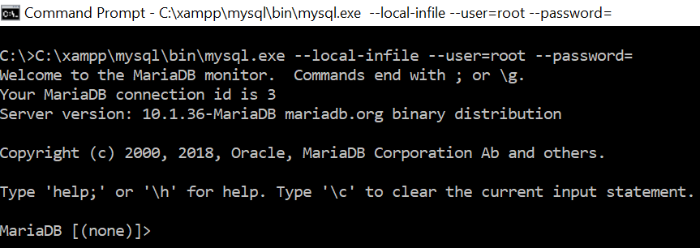
2. First we want to be sure there is no database named: mydatabase in my system. To do this we enter:
SHOW databases;
You should get:
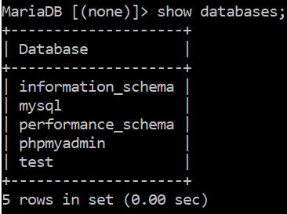
Note: You may get a slightly different pictures.
Note that MySQL is not case sensitive. There is no difference between upper and lower case letters. But we enter the instructions in upper case and our names in lower case letters. Therefore, in “DROP DATABASE mydatabase;” The part “DROP DATABASE” is a MySQL instruction and “mydatabase” is our name for the database.
3. Although we can use the database named test but we prefer to create our own. Enter:
CREATE DATABASE mydatabase;
To see:
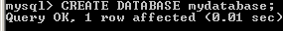
4. Now enter the following instruction to use this database:
USE mydatabase;
To see:
5. Let us create a table with the following fields:
Field’s name | Type
Firstname | VARCHAR(20)
Lastname | VARCHAR(20)
Birthdate | DATE
Dependents | INT
Ss | VARCHAR(11)

There are many types in MySQL. The above one are a few of them:
VARCHAR(20) means the name is a variable of type on an array of 20 character .
DATE means the name is of type date. Therefore DATE is a type. The type DATE is in the format of YYYY-MM-DD.
INT means the name is of type integer.
CREATE TABLE mytable (firstname VARCHAR(20), lastname VARCHAR(20), birthdate DATE, dependents INT, ss VARCHAR(11));
You should see:
Note that the instruction is all in one line.
6. To make sure we have the right layout for our table, enter:
DESCRIBE mytable;
To see:
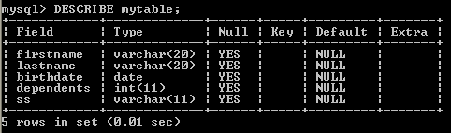
7. We now enter 20 names in the table. Obviously entering data via keyboard is a little hard and we may mistake. Therefore, we enter these names into a text file and load the text file into the table. The other advantage of this is we can use the text file for other tables and can change its content easier.
Item on the same line in the text file should be separated by one tab key. Only ONE TAB.
Jane Doe 1952-09-12 0 123-45-6789
John Doe 1944-08-23 2 213-45-6789
Adam Smith 2004-05-01 0 321-45-6789
Ann Smith 2006-06-02 1 123-54-6789
Joe Bean 1988-11-05 4 123-44-0221
Mike Smith 1999-12-22 0 234-43-1202
Sara Doe 2008-11-16 0 675-54-9845
John Reivik 1999-12-25 1 234-55-1256
Rose Nigel 1977-05-29 5 345-62-5731
William Smith 1987-10-12 0 254-67-9832
Danielle Davis 1944-12-13 6 254-23-6734
David Depaoli 1988-10-15 2 345-78-4321
Thomas Iacovelli 2000-01-01 0 345-83-5674
Dominick Olsen 1942-05-06 5 673-35-0120
John Yolas 1987-12-23 2 370-20-2298
Danielle Williams 2001-10-25 0 402-25-1002
Elaine Ramos 1977-09-08 3 204-56-7821
George Perez 1999-01-03 1 276-45-1856
Elaine Silva 2002-11-25 0 280-23-6002
Angela Dawnell 1988-09-24 1 872-56-0203

8. We save this file with the name names.txt in folder Temp in drive C.
In order to load the table with the content of this file we enter:
LOAD DATA LOCAL INFILE "C:/Temp/names.txt" INTO TABLE mytable;
To see:
Note: Be careful. You should enter the correct path.
9. Let us display the table. To display the table enter:
SELECT * FROM mytable;
We should see:

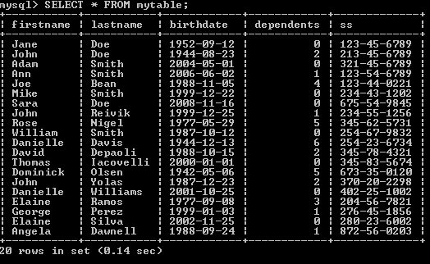
10. It is possible that we make mistake in designing the text file. For example if we pressed the tab key twice after Jane in the text file we get the following:

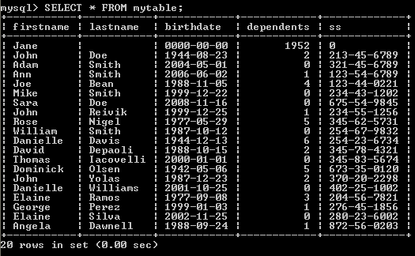
In this case we need to correct the text file, delete the content of the table, and load the text file again.
11. To delete the content of the table enter:
DELETE FROM mytable;
12. We now would like to sort the table by the last name. Enter:
SELECT * FROM mytable ORDER BY lastname;
Now let us look at the content of the table:
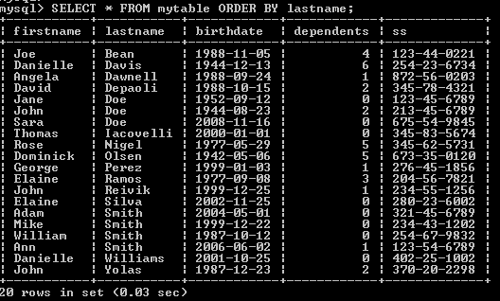
13. We also may need to search the table for a specific person. Enter:
SELECT * FROM mytable WHERE lastname = "Perez";
We see:

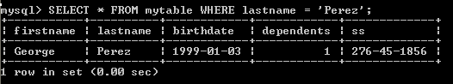

Or for:
SELECT * FROM mytable WHERE lastname = "Doe";
We see:
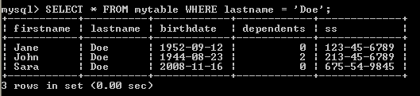

What happens if the last name is not in the table? To see enter:
SELECT * FROM mytable WHERE lastname = "XX";

We see:
The response is Empty set.
14. To select part of the information for a specific person like the first name and the date of birth of a person we write:
SELECT firstname,birthdate FROM myTable WHERE lastname="Doe";
15. To select a row based on two conditions we write:
SELECT firstname,birthdate from mytable where lastname = "Doe" and firstname = "John";

We see:
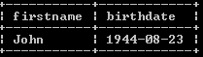
16. To insert in the table we write information for a new person:
INSERT INTO myTable (firstname, lastname, birthdate, dependents, ss) VALUES ("Mehdi", "Badii", "1959-09-12", 3, "123-12-1234");

17) We can update an item of the table:
UPDATE mytable SET lastname = "Doexxx" WHERE lastname = "Doe";
There are many instructions in MySQL. But this course is not about database management. I only want to show you how to use a database management.
18. Since I do not like to have a lot of databases I use the drop-instruction to drop the database made in the provious chapter. Enter the following:
DROP DATABASE mydatabase;
19. Finally to quit from the database manager enter:
quit;
Usefule information:
Find the version of MySQL by:
SELECT version();
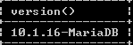
Then go to the following website to access many useful items of this version:
http://dev.mysql.com/doc/refman/5.1/en/
On this website scroll down to read its Table of Contents.

2. Working with database from a Java program:

To work with mysql within java we need to connect Java to mysql via eclipse

2.1 Downloading the MySQL JDBC Driver

JDBC stands for Java Data Base Connectivity.

1. From the blackboard download the file: mysql-connector-java-5.1.12-bin.jar

2. Copy this file into two folders:

C:\Program Files\Java\ jre1.8.0_102 \lib\ext

And:

C:\xampp\tomcat\lib

Note: It is OK if you have a different version of jre.

2.2 Writing a java program in eclipse

In this section we look at four examples. The first two are just Java program and the last two are Java servlets.

Example 2:

1. Make an empty folder and a java project named Project for eclipse. Make a class called: Main. On the menu bar click on: Project → Properties and click on Java Build Path and select tab: Libraries:

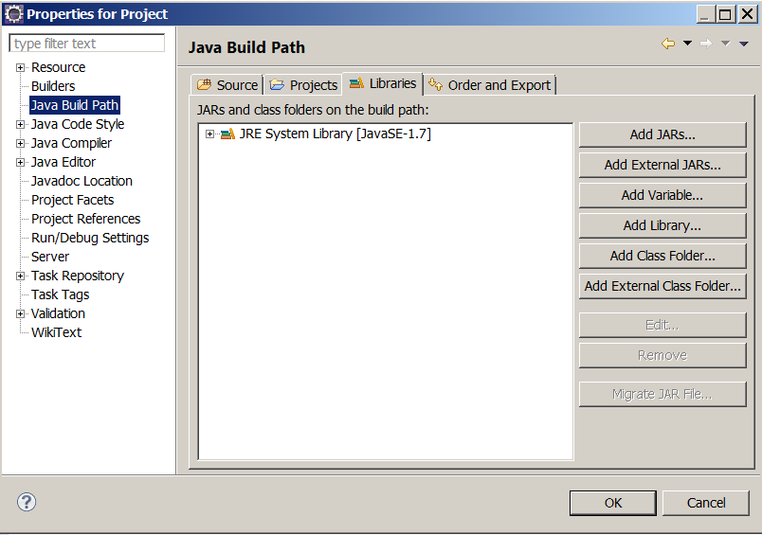

3. Click on: Add External JARs… and find the file mysql-connector-java-5.1.15-bin.jar which is in the folder:

C:\Program Files\Java\jre6\lib\ext

Note: I assume you have already copied (moved) this file to the above folder.

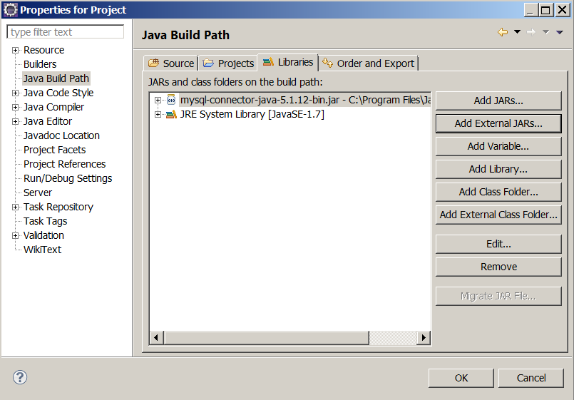

6. Click OK.

7. Copy the following classes in place of your Main class. Load XAMPP and start MySQL.

import java.sql.Connection;
import java.sql.DriverManager;

public class Main {
public static void main(String[] args) {
try {
Class.forName("com.mysql.jdbc.Driver").newInstance();
Connection conn = DriverManager.getConnection(
"jdbc:mysql://localhost/test?user=&password=");
} catch (Exception ex) {
System.out.println("LocalizedMessage: " +
ex.getLocalizedMessage());
System.out.println("Message: " + ex.getMessage());
System.out.println("Cause: " + ex.getCause());
System.out.println("Class: " + ex.getClass());
System.out.println("StackTrace: " + ex.getStackTrace());
System.exit(0);
}
System.out.println("Program terminated with no error.");
}
}

The output should be:

program terminated with no error.

Note: I did not assign any user name and password to MySQL. If you did you need to change:

"jdbc:mysql://localhost/test?user=&password=")

To:

"jdbc:mysql://localhost/test?user=YOUR-USER-NAME&password=YOUR-PASSWORD")

If your user name or password is wrong, you get:

LocalizedMessage: Access denied for user ' YOUR-USE-NAME '@'localhost' (using password: YES)
Message: Access denied for user 'YOUR-USE-NAME'@'localhost' (using password: YES)
Cause: null
Class: class java.sql.SQLException
StackTrace: [Ljava.lang.StackTraceElement;@19c26f5

If you give the wrong database name like the following in place of: test

testA

You get:

LocalizedMessage: Unknown database 'testa'
Message: Unknown database 'testa'
Cause: null
Class: class com.mysql.jdbc.exceptions.MySQLSyntaxErrorException
StackTrace: [Ljava.lang.StackTraceElement;@19c26f5

Note: The data base test is already in MySql when you install.

Description

There are two statements new in the program:

Class.forName("com.mysql.jdbc.Driver").newInstance();
Connection conn = DriverManager.getConnection(
"jdbc:mysql://localhost/test?user=&password=");

The first statement loads the JDBC driver. The second instruction establishes a connection to the database named test. Note that the database test is already in MySQL and we do not have to make it.

The URL is: jdbc:mysql://localhost/
The name of the database is: test
Note: To learn the syntax (format) of MySQL instructions refer to:

http://dev.mysql.com/doc/refman/5.0/en/drop-table.html

Example 3: Let us make a table with one row:

import java.sql.*;
import java.util.Scanner;
public class Main {
public static void main(String[] args) {
try {
Class.forName("com.mysql.jdbc.Driver").newInstance();
Connection con = DriverManager.getConnection(
"jdbc:mysql://localhost/?user=root&password="); //I
Statement stmt = con.createStatement();
stmt.execute("CREATE DATABASE IF NOT EXISTS mydatabase"); //II
stmt.execute("USE mydatabase");
stmt.execute("DROP TABLE IF EXISTS simple");
stmt.execute("CREATE TABLE IF NOT EXISTS simple( name char(30))");
stmt.execute("INSERT INTO simple VALUES(\"John Doe\")");
stmt.execute("INSERT INTO simple VALUES(\"Jane Doe\")");
ResultSet rs = stmt.executeQuery("SELECT * FROM simple");
while ( rs.next())
System.out.println(rs.getString(1));
} catch (Exception ex) {
System.out.println("Message: " + ex.getMessage());
System.exit(0);
}
System.out.println("Program terminated with no error.");
}
}

The output of this program is:

John Doe
Jane Doe
Program terminated with no error.

Description

The instruction:

Statement stmt = con.createStatement();

The variable stmt refers to an object of type of the class Statement. We send a database statement via this object to MySQL.

The instruction:

stmt.execute("DROP TABLE IF EXISTS simple");

Informs MySQL that if the table named simple exists it should be deleted.

The instruction:

stmt.execute("CREATE DATABASE IF NOT EXISTS mydatabase"); //Comment if test is used

Creates the database. Note that if you like to use the built-in database: test you need comment this instruction. The database: test is already created.

The instruction:

stmt.execute("CREATE TABLE IF NOT EXISTS simple( name char(30))");

If the table does not exist creates a table named simple with one column named name. In each row of this column we are allowed to write a string of at most 30 characters.

The instructions:

stmt.execute("Insert into simple values(\"John Doe\")");
stmt.execute("Insert into simple values(\"Jane Doe\")");

Insert the names John Doe and Jane Doe in the table. Therefore, the table has two rows.

To retrieve the table, we need an object of the type of class ResultSet. It is this object that holds the content of the table. This is the job of the following instruction:

ResultSet rs = stmt.executeQuery("Select * from simple");

The while-loop:

while ( rs.next())
System.out.println(rs.getString(1));
Iterates twice. On the first iteration it prints John Doe and on the second iteration it prints Jane Doe.

The instruction:

rs.getString(1)

Retrieves the first column (we only have one column). On the first iteration it refers to the first row and on the second iteration it refers to the second row.

Example 4: Let us make a servlet to enter names from the keyboard rather than hard coded in the program (like he previous example).

Fol1ow steps 1-6 of example 2 to add the JDBC driver.

import java.io.IOException;
import javax.servlet.ServletException;
import javax.servlet.annotation.WebServlet;
import javax.servlet.http.HttpServletRequest;
import javax.servlet.http.HttpServletResponse;
import java.sql.*;
import java.util.Scanner;

@WebServlet("/Main")
public class Main extends javax.servlet.http.HttpServlet implements
javax.servlet.Servlet {
static final long serialVersionUID = 1L;

public Main() {
super();
}

protected void doGet(HttpServletRequest request,
HttpServletResponse response)throws ServletException, IOException {

Scanner key = new Scanner(System.in);
System.out.print("Enter a name: ");
String name = key.nextLine();
try {
Class.forName("com.mysql.jdbc.Driver").newInstance();
Connection con = DriverManager.getConnection(
"jdbc:mysql://localhost/mydatabase?user=root&password=");
Statement stmt = con.createStatement();
stmt.execute("CREATE DATABASE IF NOT EXISTS mydatabase");
//Sometimes you may decide to remove the table.
//In this case uncomment the following line.
//stmt.execute("DROP TABLE IF EXISTS simple");
stmt.execute("CREATE TABLE IF NOT EXISTS simple( name char(30))");

//Note that the variable is not part of the string.
String s = "Insert into simple values(\"" + name + "\")";
if(name != null)
stmt.execute(s);
ResultSet rs = stmt.executeQuery("Select * from simple");
while ( rs.next())
System.out.println(rs.getString(1));
} catch (Exception ex) {
System.out.println(ex);
System.exit(0);
}
System.out.println("Program terminated with no error.");
}
}

Run the program few time. I run it as follows:
1. Uncomment //stmt.execute("DROP TABLE IF EXISTS simple") and run it to make sure the table is removed. I entered John Doe and the output was:

Enter a name: John Doe
John Doe
Program terminated with no error.

2. Comment the above instruction and run it. I entered Jane Doe. The output was:

Enter a name: Jane Doe
John Doe
Jane Doe
Program terminated with no error.

Note: If eclipse does not prompt for “Enter a name:” just close eclipse and re-load it.

3. I run the program again and entered my name Mehdi Badii. The output was:

Enter a name: Mehdi Badii
John Doe
Jane Doe
Mehdi Badii
Program terminated with no error.

Description: This is similar to the previous example.

Note: The most messages I get from a student asking why my project is not working is about a variable (like: name below). A variable in this kind of string must not be in single or double quotations.

//Note that the variable is not part of the string.
String s = "Insert into simple values(\"" + name + "\")";

Suppose the value of the variable: name is: John Doe. The value s in the above statement is:

"Insert into simple values(\"John Doe\")"

If you make mistake and write something like:

String s = "Insert into simple values(\"" +"name"+ "\")";

The value of s is:

"Insert into simple values(\"name\")"

Therefore be very very careful.

As a final example we write a complete client-server program.

Example 5: Similar to the program in example 4 but this time a client sends a name.

A. We make the following html document for the client side:

<!-- Main.html -->
<!DOCTYPE html PUBLIC "-//W3C//DTD HTML 4.01 Transitional//EN" "http://www.w3.org/TR/html4/loose.dtd">
<html>
<head>
<meta http-equiv="Content-Type" content="text/html; charset=ISO-8859-1">
<title>Storing the name of a client</title>
</head>
<body>
<form action="http://localhost:8080/Project/Main">
<center>
<br><br>
Enter Your name:
<input type="text" name="Aname"><br><br><br>
&nbsp;&nbsp;&nbsp;&nbsp;&nbsp;&nbsp;&nbsp;&nbsp;
&nbsp;&nbsp;&nbsp;&nbsp;&nbsp;&nbsp;&nbsp;&nbsp;
<input type="submit">
</center>
</form>
</body>
</html>

Note: The name of the eclipse project must be: Project.
This html document displays:

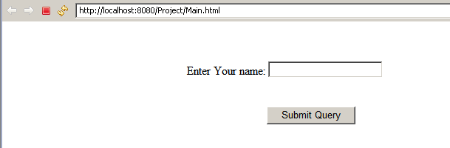

B. We make changes to the program in example 3 to have:

import java.io.IOException;
import javax.servlet.ServletException;
import javax.servlet.annotation.WebServlet;
import javax.servlet.http.HttpServletRequest;
import javax.servlet.http.HttpServletResponse;
import java.sql.*;
import java.util.Scanner;

@WebServlet("/Main")
public class Main extends javax.servlet.
http.HttpServlet implements javax.servlet.Servlet {
static final long serialVersionUID = 1L;

public Main () {
super();
}

protected void doGet(HttpServletRequest request,
HttpServletResponse response)throws ServletException, IOException {

String name = request.getParameter("Aname");
try {
Class.forName("com.mysql.jdbc.Driver").newInstance();
Connection con = DriverManager.getConnection(
"jdbc:mysql://localhost/mydatabase?user=root&password=");
Statement stmt = con.createStatement();
stmt.execute("CREATE DATABASE IF NOT EXISTS mydatabase");
stmt.execute("DROP TABLE IF EXISTS simple");
stmt.execute("CREATE TABLE IF NOT EXISTS simple( name char(30))");
//Note that the variable is not part of the string.
String s = "Insert into simple values(\"" + name + "\")";
if(name != null)
stmt.execute(s);
ResultSet rs = stmt.executeQuery("Select * from simple");
while ( rs.next())
System.out.println(rs.getString(1));
} catch (Exception ex) {
System.out.println(ex);
System.exit(0);
}
System.out.println("Program terminated with no error.");
}
}

Description

In this program we removed :

import java.util.Scanner;
Scanner key = new Scanner(System.in);
System.out.print("Enter a name: ")
String name = key.nextLine();

And added the following instruction:

String name = request.getParameter("Aname");

Therefore the servlet gets the name from the input box of the html document.
Exercise: Create a Web application that allows the user to enter a person's name (first and last), and then stores that name in a database. The Web application must provide a listing of all of the names, in alphabetical order, by last name. This listing of names must be provided in an HTML table.

For Chapter 10
CORBA
Optional

The Common Object Request Broker Architecture (CORBA) is similar to RMI. Both are dealing with remote objects. With RMI the client and server programs should be written in the same programming language. With CORBA the programming language of one side can be different than the programming language on the other side. For example we may write the server program in java and the client program in C++.

Figure 10.1 on page 310 shows the architecture of the CORBA technology.

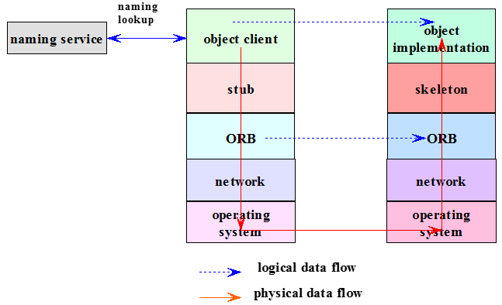

The object named: Naming Service on the left is in place of RMI registry. The server stores a unique name for the remote object in the Naming Service object. The client looks for the name and through the name retrieves the remote object. Since different languages and operating systems can be used on client and server sides CORBA has an extra layer with respect to the layers of RMI architecture. This layer is called: Object Request Broker (ORB). The ORB on both sides can resolve the differences between different programming languages and operating systems that are used on the client and the server sides.

Like the rmi interface that we have on both sides CORBA also have similar interface. Since the interface should be universal to all programming languages and operating systems we need to write it in a special language similar to C++. This language is called: Interface Definition Language (IDL). This interface is run by an IDL compiler to generate stub and skeleton (Figure 10.2 page 311).

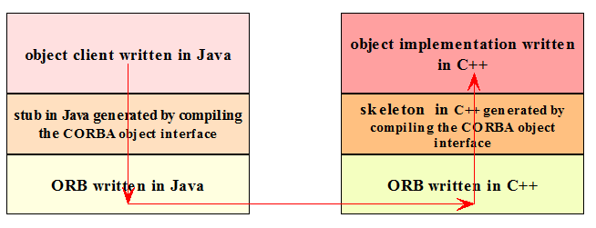

As usual let me explain some CORBA features via an example.

Example 6: The following example is the same as the one in example 1 of chapter 7 but using CORBA rather than RMI. Before describing I show you how to make the folders Server and Client:

1. In the C drive make a folder named: Example 6
2. In this folder make a folder named: Server
3. In the folder: Server make an eclipse project named: Server Project with the package name: HelloApp.
4. Make an empty text file named: Hello.idl inside the folder: src.
5. Copy the module (I) below (in page 24) in src.
6. From the DOS window go (cd) to the folder: C:\Example 6\Server\Server Project\src
7. Enter: idlj -fall Hello.idl

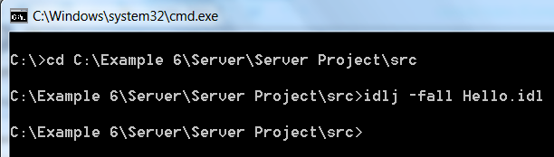

Note: The option: –fall informs the idlj compiler to generate all the necessary java files. These files is in an: app folder. For example for this example they are in the folder: HellApp.

8. In eclipse press F5 to refresh the editor. You should see the following new Java classes that the idlj compilder generated.

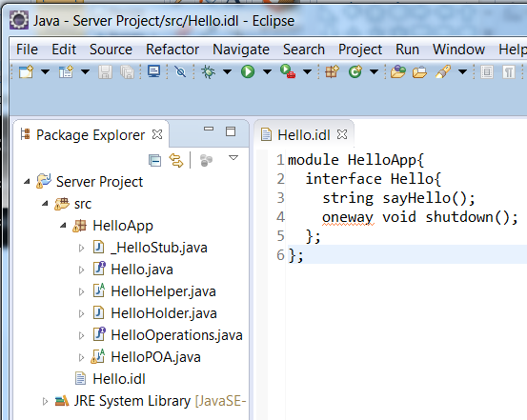

9. In the folder: Example 6 make a folder named: Client.
10. Load a second version of eclipse for the folder: Client.
10. Make a java project named: Client Project with the package name: HelloApp.
11. In the folder: C:\Example 6\Server\Server Project\src there is folder named: HelloApp and a file named Hello.idl. Take a copy of them and paste them to the folder: C:\Example 6\Client\Client Project\src.
12. In the eclipse editor for the: Client Press F5 to refresh to see:

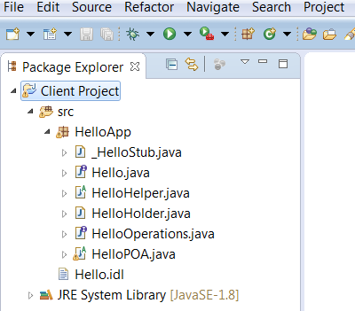

13. In the eclipse for: Server make a class named: HelloImpl and copy (II) below to it.
14. In the eclipse for: Server make a class named: HelloServer and copy (III) below to it.
At this point you the hierarchy of the classes should be:

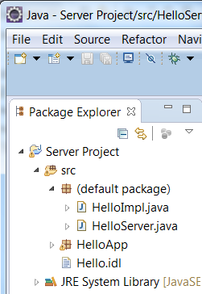

15. In the eclipse for: Client make a class named: HelloClient and copy (IV) below to it.
At this point you the hierarchy of the classes should be:

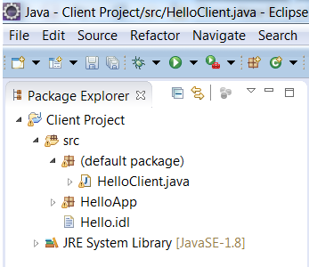

16. Go to MSDOS window and enter: start orbd -ORBInitialPort 1234
A second blank dos window pops up:

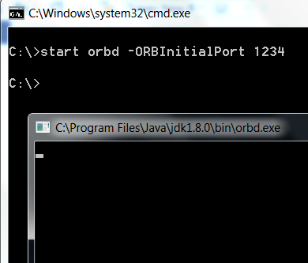

17. In eclipse for the server run the server. The following message appears on the console:

HelloServer ready and waiting ...

18. In eclipse for the client run the client. The following message appears on the console:

HelloClient: Hello, World!Donald Duck

The server:

The name of the following file must be: Hello.idl

//I: The red colored parts are the ones you may change. The rest are the ones that we repeat in any CORBA project.
module HelloApp{
interface Hello{
string sayHello();
oneway void shutdown();
};
};

//II: The red colored strings are the ones you may change. The rest are the ones that we repeat in any CORBA project.
package HelloApp;
import HelloApp.*;
import org.omg.CORBA.*;

public class HelloImpl extends HelloPOA{
private ORB orb;

public void setORB(ORB orb_val){
orb = orb_val;
}

public String sayHello(){
return "HelloClient: Hello, World!Donald Duck";
}

public void shutdown(){
//orb.shutdown(false);
}
}

//III: The red colored strings are the ones you may change. The rest are the ones that we repeat in any CORBA project.
//First go to the dos window and enter:start orbd -ORBInitialPort 1234
package HelloApp;
import org.omg.CosNaming.*;
import org.omg.CORBA.*;
import org.omg.PortableServer.*;

public class HelloServer{
public static void main(String args[]){
try{
String[] s = {"-ORBInitialPort", "1234", "-ORBInitialHost", "localhost"};
ORB orb = ORB.init(s, null);
POA rootpoa = POAHelper.narrow(orb.resolve_initial_references("RootPOA"));
rootpoa.the_POAManager().activate();
HelloImpl helloImpl = new HelloImpl();
helloImpl.setORB(orb);
org.omg.CORBA.Object ref = rootpoa.servant_to_reference(helloImpl);
Hello href = HelloHelper.narrow(ref);
org.omg.CORBA.Object objRef = orb.resolve_initial_references("NameService");
NamingContextExt ncRef = NamingContextExtHelper.narrow(objRef);
String name = "Hello";
NameComponent path[] = ncRef.to_name( name );
ncRef.rebind(path, href);
System.out.println("HelloServer ready and waiting ...");
orb.run();
}catch (Exception e) {
System.err.println("ERROR: " + e);
e.printStackTrace(System.out);
}
System.out.println("HelloServer Exiting ...");
}
}

The client:

//IV: The red colored strings are the ones you may change. The rest are the ones that we repeat in any CORBA project.

package HelloApp;
import org.omg.CosNaming.*;
import org.omg.CosNaming.NamingContextPackage.*;
import org.omg.CORBA.*;

public class HelloClient{
static Hello helloImpl;

public static void main(String args[]){
try{
String[] s = {"-ORBInitialPort", "1234", "-ORBInitialHost", "localhost"};
ORB orb = ORB.init(s, null);
org.omg.CORBA.Object objRef =
orb.resolve_initial_references("NameService");
NamingContextExt ncRef = NamingContextExtHelper.narrow(objRef);
String name = "Hello";
helloImpl = HelloHelper.narrow(ncRef.resolve_str(name));
System.out.println(helloImpl.sayHello());
helloImpl.shutdown();

}catch (Exception e){
System.out.println("ERROR : " + e) ;
e.printStackTrace(System.out);
}
}
}

Description:

The IDL file: Hello.idl

module HelloApp{
interface Hello{
string sayHello();
oneway void shutdown();
};
};

This is an IDL module. It acts as a container of an interface. CORBA objects are defined in OMG IDL (Object Management Group Interface Definition Language). The language is similar to C++. There is a compiler named: idlj (read page 318: idl to java) that translates an IDL-module to a number of interfaces and classes. Like a java interface an IDL module defines only the signature of the methods (functions, operations). The above IDL module describes a CORBA object that its: sayHello() method returns a string and shutdown() method shuts down the ORB (Object Request Broker) layer.

The idlj compiler translates the above module to the following interfaces and classes:
- public interface HelloOperations: This interface contains the signature of the methods that the client can call.

- public interface Hello extends HelloOperations, org.omg.CORBA.Object, org.omg.CORBA.portable.IDLEntity: This is called a signature interface. It is an empty interface that extends the above corba interfaces and operation interface: HelloOperations. This interface has the signature of two methods: String sayHello () and String sayHello ().

- abstract public class HelloHelper: Provides auxiliary functionality needed to support a CORBA object in the context of the Java language.

- public final class HelloHolder implements org.omg.CORBA.portable.Streamable: It provides operations for output to and input from arguments

- public class _HelloStub extends org.omg.CORBA.portable.ObjectImpl implements HelloApp.Hello: It implements the interface: Hello which extends the interface HelloOperations. In this class we have the definition of the method: sayHello(). But in this definition we do not see “return a string”. We see: $out = _request ("sayHello", true). It is this statement that on the server side refers to the class: HelloImpl. It is the class HelloImpl that has the actual code in the body of method: sayHello.

- public abstract class HelloPOA extends org.omg.PortableServer.Servant implements HelloApp.HelloOperations, org.omg.CORBA.portable.InvokeHandler: This is the skeleton object (the server side proxy). It is this object that un-marshals the arguments received from the client.

The above packages, classes, and interfaces are what we do all the time for a CORBA client-server project. Therefore we do not need to get into the details of them.
Note: We are accepting java packages, classes, and interfaces all the times. We are not interested how they are implemented.

The Server:

The class HelloImpl:

The class ORB: The ORB (Object Request Broker) object: orb is responsible to pass a client request an object and to return results back to the clients. For further information see: http://docs.oracle.com/javase/7/docs/api/org/omg/CORBA/ORB.html.
The call: orb.shutdown(false) shuts down the communication between the client and the server.

The class HelloServer:
String[] s = {"-ORBInitialPort", "1234", "-ORBInitialHost", "localhost"}: In this string we specify the port (i.e. 1234) and the host IP (i.e. local host).

ORB orb = ORB.init(s, null): The static method: init creates a new object from the class: ORB. The parameter: s is an array of stings.
You can omit the boldfaced-italic part of this command. In this case the system is using the default port (usually: 80) and the localhost.
POA rootpoa = POAHelper.narrow(orb.resolve_initial_references("RootPOA")): POAHelper is a java class and: narrow is one of its static method.
- orb.resolve_initial_references("RootPOA"): This method call finds part of CORBA infrastructure. The argument: "RootPOA" indicates which piece of CORBA to find.
- narrow: Narrows down to a portable server.

rootpoa.the_POAManager().activate():This method changes the state of the POA manager to active, causing associated POAs to start processing the request.

helloImpl.setORB(orb): Passes the object: orb to the class HelloImpl.

org.omg.CORBA.Object ref = rootpoa.servant_to_reference(helloImpl): Makes the CORBA object: ref to associate with the servant (which is serves HelloImpl object).

Hello href = HelloHelper.narrow(ref): Narrows down to a portable server. Hello is our interface defined in the above IDL module.

org.omg.CORBA.Object objRef = orb.resolve_initial_references("NameService"): This method finds the object whose name is: NameService.

NamingContextExt ncRef = NamingContextExtHelper.narrow(objRef): NamingContextExt is a java interface. This interface is inherited from another java interface named: NamingContext. The method: narrow casts to a specific name (See figures 10.4 & 10.5 in pages 314-315).

helloImpl = HelloHelper.narrow(ncRef.resolve_str(name)): This is the name (i.e. "Hello") that the client should use to access to the remote object. This is an optional name. We can change it to any name.

helloImpl.sayHello(): Returns the message: "HelloClient: Hello, World!Donald Duck" to the client.

helloImpl.shutdown(): Finally the server closes its door to the client.

The Client: The classes, interfaces and methods are all the same as the ones in the server program.

Chapter 11

In this chapter we study simple applets with respect to servlets.

11.1 Applets

Applets are less powerful than sockets, RMIs and servlets. However it is the applet that can draw lines and shapes. An applet is a java class. We can easily implement an applet when it is in the remote server together with its html document. We specify the name of the java class (the class file and not its java file) and the size of the applet in the html document. Upon an http request from a client the browser on the server loads the html document, finds the name of the class, executes it and responds to the client HTTP request.

Example 7: The following program displays a number of circles with different colors.
Note: The detailed materials for applets are beyond the subject of this course. I teach applets in IT 608 (Network Programming II) in detailed.

import java.applet.Applet;
import java.awt.*;

public class Main extends Applet {
Color [] c =
{
Color.BLACK, Color.BLUE, Color.CYAN, Color.DARK_GRAY, Color.GRAY,
Color.GREEN, Color.LIGHT_GRAY, Color.MAGENTA, Color.ORANGE,
Color.PINK, Color.RED, Color.YELLOW
};

public void init(){
setSize(400, 400);
}

public void paint(Graphics page){
int x = 10, y = 10, w = 300, h = 300, index = 0, delta = 10;
for(int i = 1; i <= 12; i++){
page.setColor(c[index++]);
page.fillOval(x, y, w, h);
x += delta;
y += delta;
w -= 2 * delta;
h -= 2 * delta;
}
}
}

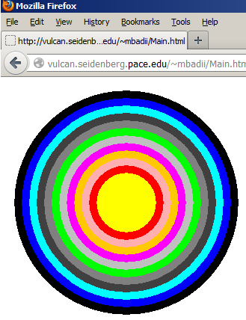

Example 8: The following program creates a text field and a button. When the user clicks on the button the content of the text field changes.

import java.applet.*;
import java.awt.event.*;
import java.awt.*;

public class Main extends Applet implements ActionListener, WindowListener {
private static final long serialVersionUID = 1L;

Frame myFrame;
TextField myTextField;
Panel topPanel;
Panel buttonPanel;
Button myButton;

public void init () {
buildGUI ();
}

public void actionPerformed ( ActionEvent e ) {
myTextField.setText("Hello World");
}

public void windowActivated ( WindowEvent e ) {
}

public void windowDeactivated ( WindowEvent e ) {
}

public void windowOpened ( WindowEvent e ) {
}

public void windowClosed ( WindowEvent e ) {
}

public void windowClosing ( WindowEvent e ) {
myFrame.setVisible(false);
myFrame.dispose ();
System.exit(0);
}

public void windowIconified ( WindowEvent e ) {
}

public void windowDeiconified ( WindowEvent e ) {
}
private void buildGUI () {
myTextField = new TextField ("XXXXXXXXXX" , 30 );
topPanel = new Panel ();
topPanel.setLayout ( new GridLayout ( 2, 1 ) );
topPanel.add (myTextField);
myButton = new Button ("Click Me");
myButton.addActionListener ( this );
buttonPanel = new Panel ( );
buttonPanel.add ( myButton );
myFrame = new Frame ("A Frame");
myFrame.addWindowListener ( this );
myFrame.add ( "North", topPanel );
myFrame.add ( "South", buttonPanel );
myFrame.setSize( 400, 450 );
myFrame.setVisible(true);;
}
}

Example 9: In the following client-server programs the client sends a message to the server. The server responds with a thank-you message back to the client. The client then writes the message on its applet.

import java.applet.Applet;
import java.awt.*;
import java.io.*;
import java.net.*;
import java.util.Scanner;

public class MyClient extends Applet {
private String s;

public void init(){
setSize(400, 100);
try{
Scanner keyboard = new Scanner(System.in);
InetAddress host = InetAddress.getByName("localhost");
Socket clientSocket = clientSocket = new Socket(host, 16790);
PrintWriter out = new PrintWriter(clientSocket.getOutputStream(), true);
System.out.print("Enter a message to be sent to the server: ");
String a = keyboard.nextLine();
out.println(a);
BufferedReader in = new BufferedReader(new InputStreamReader(clientSocket.getInputStream()));
s = in.readLine();
}catch(Exception e){
System.out.println("Error: " + e);
}
}

public void paint(Graphics page){
page.drawString(s, 20, 20);
}
}

import java.io.*;
import java.net.*;

public class MyServer {
public static void main(String[] args){
ServerSocket serverSocket = null;
try {
serverSocket = new ServerSocket(16790);
Socket clientSocket = null;
clientSocket = serverSocket.accept();
BufferedReader in = new BufferedReader(new InputStreamReader(clientSocket.getInputStream()));
String s = in.readLine();
PrintWriter out = new PrintWriter(clientSocket.getOutputStream(), true);
out.println("Thank you for telling me: " + s);
in.close();
out.close();
clientSocket.close();
serverSocket.close();
} catch (IOException e) {
System.out.println("Error: " + e);
System.exit(0);
}
}
}

Input-output dialog:

The client program reads the message: Have a nice day

Enter a message to be sent to the server: Have a nice day

From the console and sends it to the server.

The server program gets this message and sends the message:

Thank you for telling me: Have a nice day

The client program draws this string on its applet:

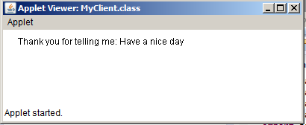

Enter a message to be sent to the server: Have a nice day

Description

The concept of socket programming is explained in lecture 3.

Example 10: In the following example the client sends a message from its gui frame and sends it to the server (servlet) through a socket. The servlet displays the message on the html document. This example shows that we can combine the client-server program with GUI. On the client side the following applets shows up. When the user enters a user name, a password and clicks on the button Register (or Login) the content of the applet as a string will be sent to the server side to a servlet. The servlet echoes this string on an html page. In the following execution I entered: John for the user name abcd for the password, and selected the Register button.
Note: Change the port to: 1234

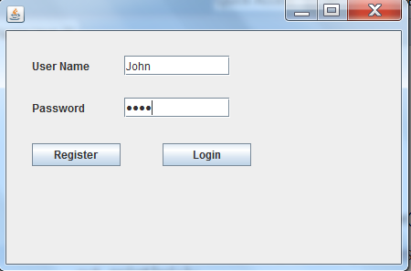

The servlet displays the following page. Note that since the second input box is a password box the password: abcd shows in a encrypted format:

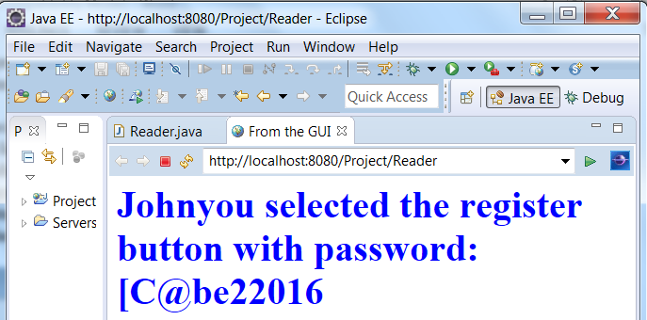

The server:

import java.io.*;
import java.net.*;
import java.util.StringTokenizer;
import java.io.IOException;
import javax.servlet.ServletException;
import javax.servlet.annotation.WebServlet;
import javax.servlet.http.HttpServlet;
import javax.servlet.http.HttpServletRequest;
import javax.servlet.http.HttpServletResponse;

@WebServlet("/Reader")
public class Reader extends HttpServlet {
private static final long serialVersionUID = 1L;

public Reader() {
super();
}

protected void doGet(HttpServletRequest request, HttpServletResponse response)
throws ServletException, IOException {
String s = receiver();
StringTokenizer tok = new StringTokenizer(s);
String selected = tok.nextToken();
String user = tok.nextToken();
String pass = tok.nextToken();
PrintWriter out = response.getWriter();
out.println("<html><title>From the GUI</title><body><font color = blue><h1>" +
user + "you selected the " + selected + " button with password: " + pass +
"</h1></font></body></html>");
out.close();
}

private String receiver(){
ServerSocket serverSocket = null;
String s = "";
try {
serverSocket = new ServerSocket(1234);
Socket clientSocket = null;
clientSocket = serverSocket.accept();
BufferedReader in = new BufferedReader(new
InputStreamReader(clientSocket.getInputStream()));
s = in.readLine();
clientSocket.close();
serverSocket.close();
}catch (IOException e) {
System.out.println("Error: " + e);
System.exit(0);
}
return s;
}
}

The client:

import java.awt.EventQueue;
import javax.swing.*;
import java.awt.event.ActionListener;
import java.io.*;
import java.net.*;
import java.awt.event.ActionEvent;
import javax.swing.border.EmptyBorder;

public class MyFrame extends JFrame {
private static final long serialVersionUID = 1L;
private JPanel contentPane;
private JTextField user;
private JPasswordField password;

public static void main(String[] args) {
EventQueue.invokeLater(new Runnable() {
public void run() {
try {
MyFrame frame = new MyFrame();
frame.setVisible(true);
} catch (Exception e) {
e.printStackTrace();
}
}
});
}

public MyFrame() {
setDefaultCloseOperation(JFrame.EXIT_ON_CLOSE);
setBounds(100, 100, 450, 300);
contentPane = new JPanel();
contentPane.setBorder(new EmptyBorder(5, 5, 5, 5));
setContentPane(contentPane);
contentPane.setLayout(null);

user = new JTextField();
user.setBounds(129, 27, 116, 22);
contentPane.add(user);
user.setColumns(10);

JLabel lblUserName = new JLabel("User Name");
lblUserName.setBounds(28, 30, 89, 16);
contentPane.add(lblUserName);

JLabel lblNewLabel = new JLabel("Password");
lblNewLabel.setBounds(28, 76, 79, 16);
contentPane.add(lblNewLabel);

JButton btnRegister = new JButton("Register");
btnRegister.addActionListener(new ActionListener() {
public void actionPerformed(ActionEvent arg0) {
String s = "register " + user.getText() + " " +
password.getPassword().toString().trim();
send(s);
}
});
btnRegister.setBounds(28, 123, 97, 25);
contentPane.add(btnRegister);

JButton btnLogin = new JButton("Login");
btnLogin.addActionListener(new ActionListener() {
public void actionPerformed(ActionEvent arg0) {
String s = "login " + user.getText() + " " +
password.getPassword().toString().trim();
send(s);
}
});
btnLogin.setBounds(171, 123, 97, 25);
contentPane.add(btnLogin);

password = new JPasswordField();
password.setBounds(129, 73, 116, 22);
contentPane.add(password);
}

private void send(String s){
Socket clientSocket = null;
int port;
try {
port = 1234;
InetAddress host = InetAddress.getByName( "localhost");
clientSocket = new Socket(host, port);
PrintWriter out = new PrintWriter(clientSocket.getOutputStream(), true);
out.println(s);
out.close();
clientSocket.close();
}catch (IOException e) {
System.out.println("Error: " + e);
System.exit(0);
}
}
}

Description:

On the client side if the user selects the login button the following method is executed:

public void actionPerformed(ActionEvent arg0) {
String s = "login " + user.getText() + " " +
password.getPassword().toString().trim();
send(s);
}
We begin the string with the word: "login " to be able to determine the string is for the login button. This word and the content of the input boxes labeled: User Name and Password are added to the string. These three words are separated by a single space. It is this string that is sent to the servlet by using sockets. If the user clicks the register button the following event handler gets executed:

public void actionPerformed(ActionEvent arg0) {
String s = "register " + user.getText() + " " +
password.getPassword().toString().trim();
send(s);
}

The only difference in the string is the word: "register " with respect to the above handler.

On the server side this string is tokenized and the three words of the string are extracted by the following code:

String s = receiver();
StringTokenizer tok = new StringTokenizer(s);
String selected = tok.nextToken();
String user = tok.nextToken();
String pass = tok.nextToken();

The servlet then makes an html string with these three words:

PrintWriter out = response.getWriter();
out.println("<html><title>From the GUI</title><body><font color = blue><h1>" +
user + "you selected the " + selected + " button with password: " + pass +
"</h1></font></body></html>");

The advantage of an applet over a html document is the drawing facilities. Window builder is capable to add objects such as text fields, buttons objects to make a GUI interface. But for drawing it does help. The code for drawing part should be written by the programmer. Let us see how much of this helps in drawing.

The major methods for an applet are:
init: When an applet is implemented this method is executed first.
start: When the user visits or revisited an applet, this method is executed.
run: Method start calls this method.
stop: When the user leaves an applet or closes the applet this method is executed.
destroy: When an applet completes its execution and the user closes the browser page this method is executed.

Note that these methods originally are defined in the Java class Applet or JApplet. When a programmer defines any of these methods in her/his program she/he is overriding these methods.

If we like to draw shapes we redefine the method paint. In the following program we are overloading (redefine) this method.

Example 11: The following program changes the default font and loads the picture below in an applet. Note that you need to have this picture in the folder: bin of your project’s folder.

import java.awt.*;
import javax.swing.JApplet;

public class Main extends JApplet {
private Image img;

public void init(){
setSize(400, 400);
this.setFont(new Font("Tahoma",3,24));
img = getImage(getCodeBase(), "nature.gif");
}

public void start(){
setSize(400, 400);
}

public void paint(Graphics page){
page.drawString("Nature", 130, 30);
page.drawImage(img, 10, 40, 300, 300, this);
}
}

The display output is:

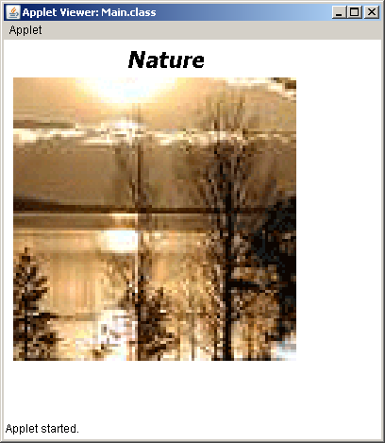

Description:

this.setFont(new Font("Tahoma",3,24)): The word: this refers to this applet object. Therefore the font of characters written on the applet by the instruaction: page.drawString("Nature", 130, 30) is: Tahoma, the size of each character is: 24 pixels and the number: 3 makes the character is as boldfaced and italic ( 1 means default, and 2 means boldfaced).

img = getImage(getCodeBase(), "nature.gif"): The call: getCodeBase() gets the base URL. This is the URL of the folder: bin. Therefore the variable: img refers to an image obect.

page.drawImage(img, 10, 40, 300, 300, this): Draws (loads) the picture object on this applet. The location of its upper-left corner is: x = 10, and y = 40 pixels. Its width of the height are 300.

Note: To be able to load the applet with a desired size to a browser on the menu bar click on: Run → Run Configurations and select the tab: Parameters to see:

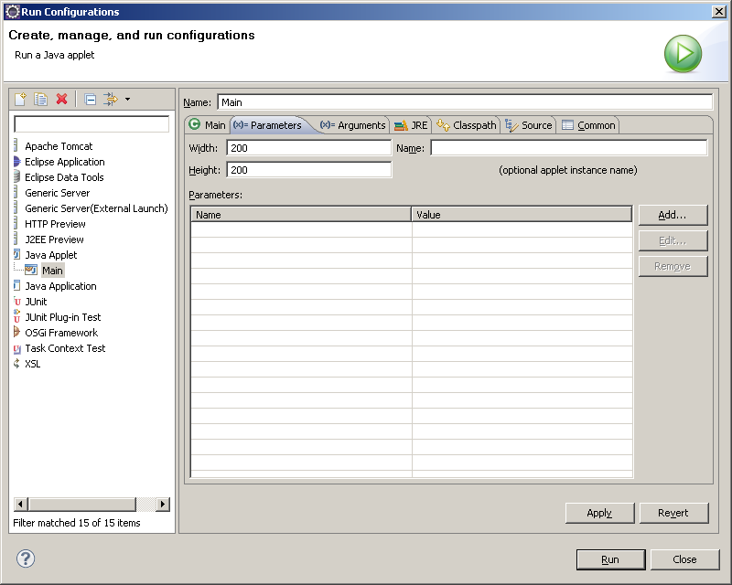

Change both 200 (e.g. to 400). Click on: Apply and then: Close. Now while your program is running go to the folder: bin in your priject’s folder. There is an html file. Copy/paste it. Terminate your program in elclipse and load your html.

The method: paint has a counter part named: repaint(). This method calls the method: paint.

Example 12: We would like to make a digital clock on an applet.

import java.awt.Color;
import java.awt.Font;
import java.awt.Graphics;
import java.text.DateFormat;
import java.util.Date;

import javax.swing.JApplet;

public class Main extends JApplet implements Runnable{
String s;
Thread t;

public void start() {
t = new Thread(this);
t.start();
}

public void run() {
while(true){
Date today = new Date();
DateFormat df = DateFormat.getTimeInstance();
s = df.format(today.getTime());
repaint();
try {
t.sleep(1000);
} catch (InterruptedException e) {
e.printStackTrace();
}
}
}

public void paint(Graphics page){
page.clearRect(0, 0, 200, 200);
Font f = new Font("Serif", Font.BOLD, 20);
page.setFont(f);
page.setColor(Color.black);
try{page.drawString(s, 10, 100);}catch(Exception e){}
}
}

The class JApplet has a method called: paint with the exact signature (heading) of the one in the class: Main. Therefore we are overriding this method. Since we have: implements Runnable the class Main is capable to create a thread object.

Automatically the method: start is executed. In this method we create a thread object and call start (t.start()). This make the method: run gets executed.
Method: run

- Date today = new Date(): A Date object to find the time of the day.The variable today is referring to this object.

- DateFormat df = DateFormat.getTimeInstance(): A format object to format the time.

- today.getTime(): Returns the current time.

- s = df.format(today.getTime()): df.format(today.getTime()): Makes a string that is the format of the time in the form of: hh:mm:ss followed by either AM or PM. This string would be the value of the variable: s. The method format has several signatures. The call of the method format with one argument makes the format of the time in the form of hh:mm:ss AM or hh:mm:ss PM. There are other definitions for this method that can be used to shape the time in different formats.

- repaint(): This is a method defined in the class of JApplet. In the body of this java method there is a call to method paint.

- sleep(1000): Makes the execution to wait for one second. Therefore after every second the method paint is called.

When the applet appears on the screen the method: paint is called. This method does the following:
Method: paint
- page.clearRect(0, 0, 200, 200): Clears the area of the applet by painting the background of the applet. The area is a rectangle with width and height 200.
- Font f = new Font("Serif", Font.BOLD, 20): Defines the font of any text written on the applet Serif, bold and the size of each character of the text 20.
- page.setFont(f):The font of the text that are going to be written on the applet is set.
- pageg.setColor(Color.black):To write a text in black color.
- pag.drawString(s, 10, 100): The string of variable s is written stating at the coordinate x = 10, and y = 100 on the applet.

Exercise: Write a client-server program using socket and applet to do the following:
The servlet send a message to the client to draw a 2-D shape on the applet with the following information:
a) Triangle with the x-y coordinates of the three angles.
b) Rectangle with the x-y coordinates of the four angles.
c) Circle with the x-y coordinate of the center and the radius.

